Understanding the Demographics and Topics That Impacted the Spread of COVID-19

By

Lacey B. Gould

A Thesis submitted to the Graduate Faculty of
Elizabeth City State University
In partial fulfillment of the requirements
For the Degree of
Master of Science in Mathematics

April

2023

Approved by

Mohammed Talukder, Ph.D. Julian Allagan, Ph.D.
Committee Chairperson Committee Member

Elbakary Mohamed, Ph.D. Gabriela Del Villar, Ph.D.
Committee Member Committee Member

Understanding the Demographics and Topics that impacted the Spread of COVID-19

Abstract

March 2019 changed the way of world and the way that we live, permanently. The world shut down in a way that we never thought it would. Schools shut down, businesses closed, some even permanently and only “essential workers” were working. However, the one essential place that remained open was hospitals. Hospitals had an influx of people like never before all because of Coronavirus disease or what we call COVID-19. Most people infected with the virus will experience mild to moderate respiratory illness and will recover without treatment; However, some will not. They ended up seriously ill and required medical attention and, in some cases, died. This study concludes that demographics such as race, age and sex do in fact play a part in whether it will cause death or just result in ICU.

Dedication

Thank you to Higgins, for the continued push and encouragement when I needed it most. Thank you, Ms. Hinton, for the input when I needed it most, and for leading me in the right direction. Dr. Jones… THANK YOU for everything. You weren’t there to see me cross the finish line, but you prepared me. This degree is dedicated to the three of you. You three have been beyond good to me. You are my chosen family, and words cannot express how much I appreciate the three of you. No matter what you set your mind to, or the obstacles that you may encounter, but with the right people on your side, along with God then nothing is impossible.

Acknowledgments

This degree is because of Dr. Kenneth L. Jones and Ms. Hinton. They are the ones that pushed me to come back, especially Dr. Jones, and to further my education in Mathematics. You two have helped me to become the person and I am today and the teacher that I have become. If it weren’t for you and your continued love and support. Thank you to Dr. Allagan, and Dr. Talukder for the last-minute changes and for helping me to get across the finish line. Elizabeth City State University has been my second home since Fall of 2010 when I started my journey as an Undergrad student. Thank you to all the committee members for serving without even knowing me.

Table of Content

Chapter 1: Introduction………………………………………………………………………... 1
  - What is COVID
  - How does it Spread
  - Incubation Period
Chapter 2: Data and Literature Review………………………………………………………. 3
2.1 Cases in NC
2.2 Male Vs. Female Death Rate
2.3 Hospitalizations
2.4 Death Rate
2.5 What does this data Represent
Chapter 3: Methods …………………………………………………………………………... 15
3.1 Mathematical Modeling
3.2 SIR Model
3.3 Chi-Square test (Contingency Table)
3.4 Odd Ratio
Chapter 4: Results …………………………………………………………………………….. 19
4.1 Odd Ratio
4.2 Age – ICU vs. Death
4.3 Age – Hospitalization vs. Death
4.4 Sex – ICU vs. Death
4.5 Sex – Hospitalization vs. Death
Chapter 5: Conclusion ………………………………………………………………………... 22
5.1 Summary
5.2 Primary Findings from Study
5.3 Ways to Improve Future Studies

List of Figures

- COVID Cases in NC ……………………………………………………………………...3
- Death COVID cases in NC ……………………………………………………………….3
- Male vs Female Death Rates …………………………………………………………….4
- Hospital Rates …………………………………………………………………………...11
- Deaths per Day ………………………………………………………………………….12
- Chi- Square Test ………………………………………………………………………...15
- Odds Ratio ………………………………………………………………………………17
- Age – ICU vs. Death ……………………………………………………………………18
- Age – Hospitalization vs. Death ………………………………………………………...19
- Sex – ICU vs. Death …………………………………………………………………….20
- Sex – Hospitalization vs. Death …………………………………………………………21

Chapter 1: Introduction

1.1 What is COVID
According to the World Health Organization, The Coronavirus disease (COVID-19) is an infectious disease cause by the SARS-coV-2 virus. March 2020 the world shut down in when into lock down for months. School closed, businesses closed and even schools shut down. We were living in times that we had never seen, but just read about. People were scared to come out their houses. For the first time families didn’t gather and were depending solely on technology.
People that typically get infected with the virus will experience mild to moderate respiratory illnesses and recover without requiring treatment; However, there are some cases where some will become seriously ill and require medical treatment. Older people and those with underlying medical conditions such as cardiovascular disease, diabetes, chronic respiratory disease, or cancer are more likely to become seriously ill. Anyone of any age can get sick with COVID-19 and become seriously ill or die at any age.

1.2 How does it spread?
Per John Hopkins, researchers know that the coronavirus is spread through droplets and virus particles released into the air when an infected person breathes, talks, laughs, sings, coughs, or sneezes. It also shows that larger droplets may fall to the ground in a few seconds, but the tiny infectious particles can linger in the air and accumulate in indoor places, especially where people are gathers in large groups. Poor ventilation can cause the spread to be faster than normal so the best way to protect, prevent and slow down the transmission of the virus would be to stay at least 1 meter apart, per The World Health Organization. Wear a proper fitted mask and washing your hands or using alcohol-base sanitizer frequently. Getting vaccinated also plays a key in the spread of COVID.
1.3 Incubation Period
Symptoms show up in people from anywhere between 2 to 14 days of exposure. A person that could be infected with the coronavirus is contagious to others for up to two days before symptoms appear, and they remain contagious to others anywhere from 10 to 20 days, depending on their immune system and the severity of their illness. The list of Symptoms of COVID-19 from the John Hopkins of Medicine include:
- Cough
- Fever or chills
- Shortness of breath or difficulty breathing
- Muscle or body aches
- Sore throat
- New loss of taste of smell
- Diarrhea
- Headache
- New fatigue
- Nausea or vomiting
- Congestion or runny nose

Chapter 2: Data and Literature Review
2.1 Cases in NC
Now, taking the research and zooming in on one location, the state of North Carolina, we are able to see just how we have played a part in the spread of covid and how many have been infected resulting in being in the ICU or even death. According to John Hopkins University, we have had a total of 3,472,644 cases. For the last year alone, we have had 858,045 total cases 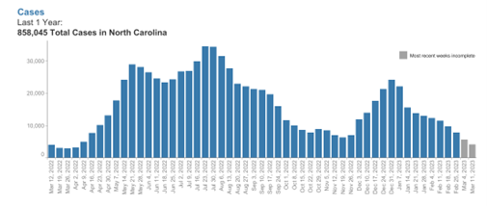
From those cases from the past year, they have resulted in a total of 3,950 deaths. This is just in the past year.
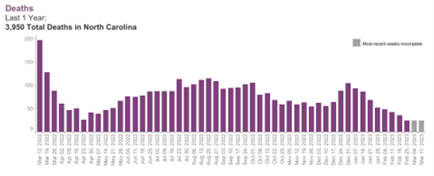

2.2 Male vs. Female Death Rate

Sex | Hospitalizations | ICU | Deaths
Male | 14020 | 186 | 17551
Female | 16516 | 2671 | 15809
Total | 30536 | 2857 | 333360
Now, taking a deeper look in analyzing the actual number of deaths that we have had from 2020 until 2023 in terms of males and females pertaining all ages so we can see just who all was infected during this pandemic. The Center for Disease Control and Prevention (CDC) provided the information below. Per their website, we can see that a total of 33,360 people died from causes of COVID-19. Out that that adults over the age of 85 were hit the hardest with 8,327 resulting in death. Those individuals are the ones that had preexisting conditions and couldn’t fight it off. So, my next question would be, how many men and how many women died and is there a trend based on sex?

Table 1- Male vs. Female

The data from table 1 was then broken down into Male vs. Female. In total, 17,551 Males died, and 15,509 Females died. Males are typically ones that have more health problems because they don’t take care of themselves, like females do. They also can tend to have more preexisting health conditions, which may be why more males died than females.
To take this research a step further did race play a part in this pandemic? Meaning, did certain individuals have access to good health care, while others didn’t?
2.3 Hospitalizations
Looking at the demographics and in terms of how each one contributes to the spread of COVID. The research that I found on the NC DOT website shows a breakdown of race, ethnicity, age and sex for these reporting weeks. The first full reporting week for the state of North Carolina based on the NC DOT website, is October 3, 2020, and it runs until March 11, 2023. For every three months, I have pulled the data so that we see if there is a trend in the number of confirmed/ admitted cases among: Race, Age, Ethnicity and Sex (Gender).

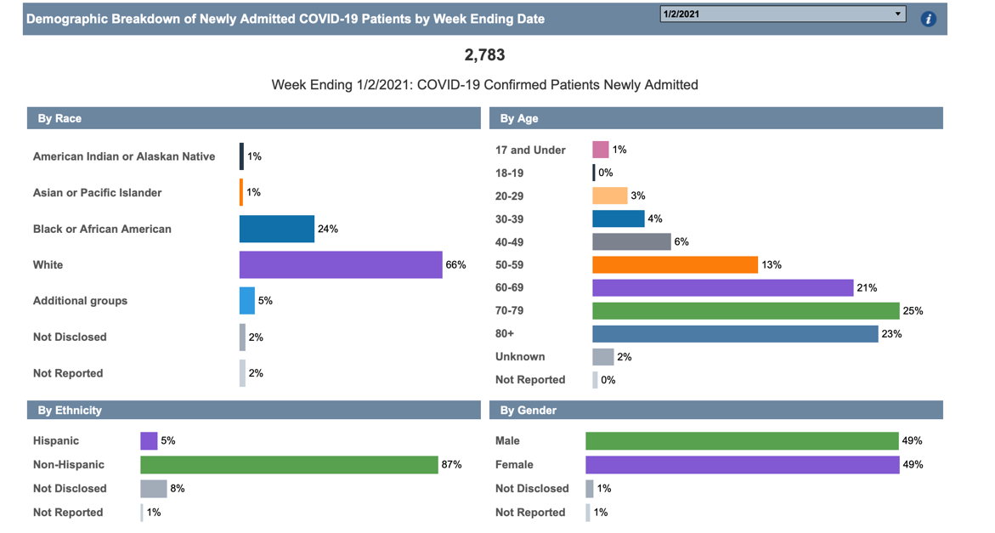
January 2, 2021, with 2,783 Confirmed/Admitted newly cases
October 3, 2020, with a total of 370 Confirmed/Admitted newly cases.
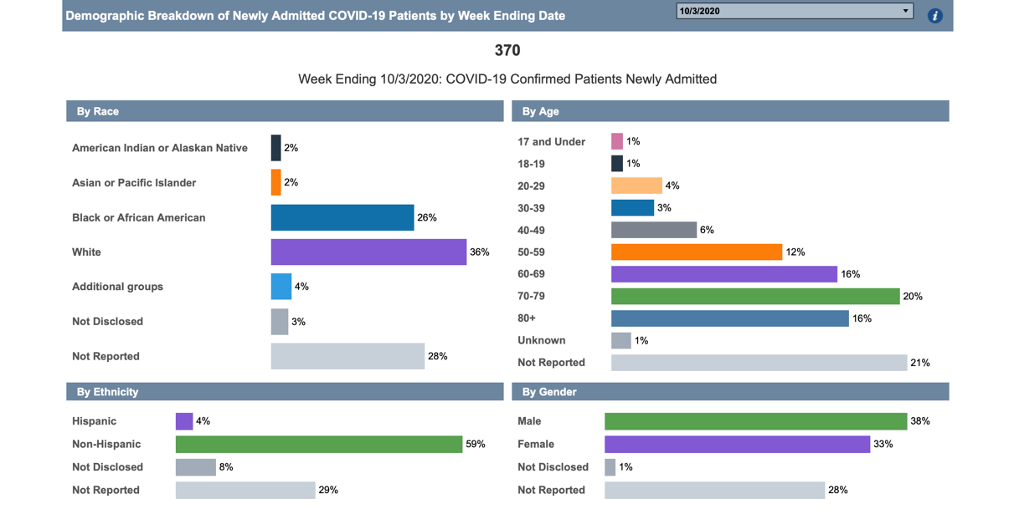

April 3, 2021, with 880 Confirmed/Admitted newly cases
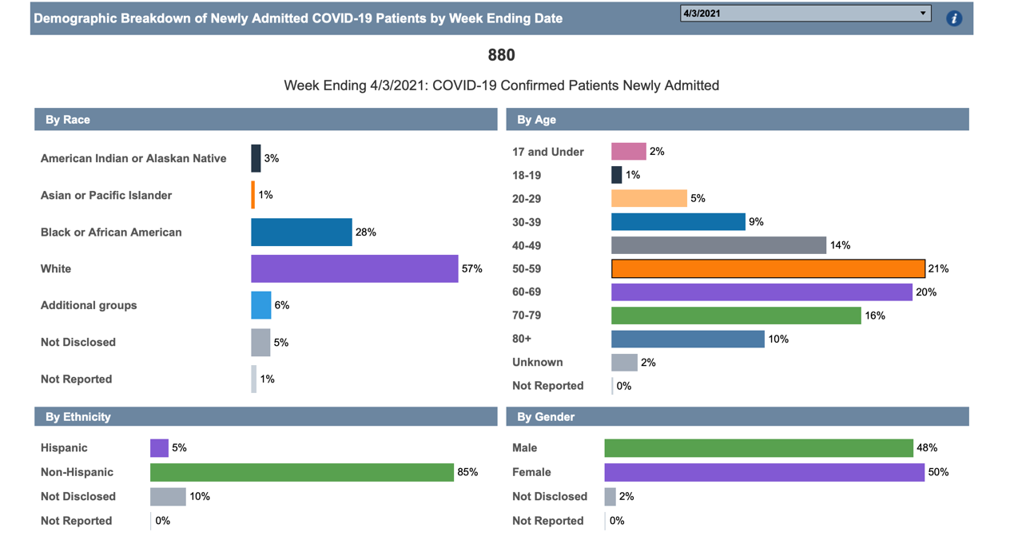

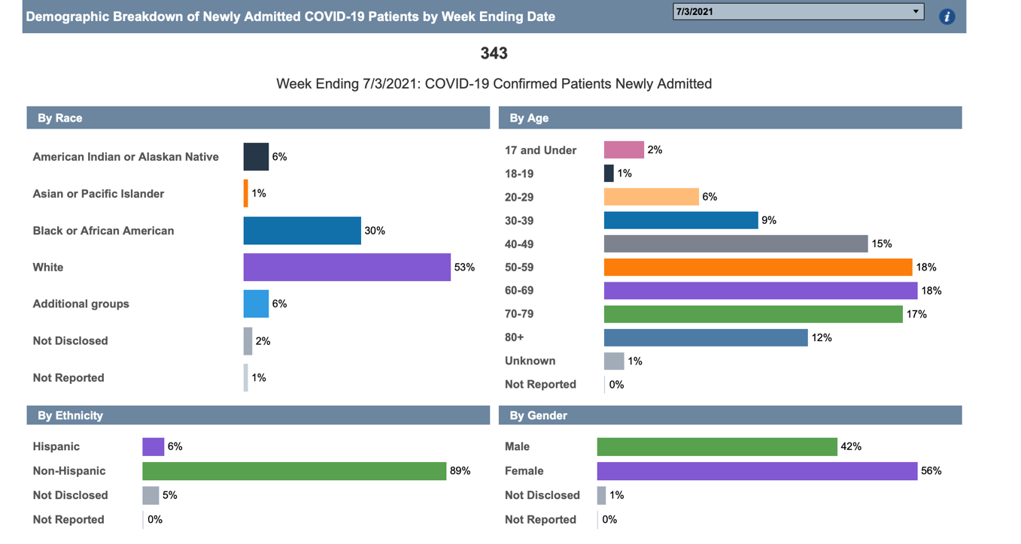
July 3, 2021, with 343 Confirmed/Admitted newly cases

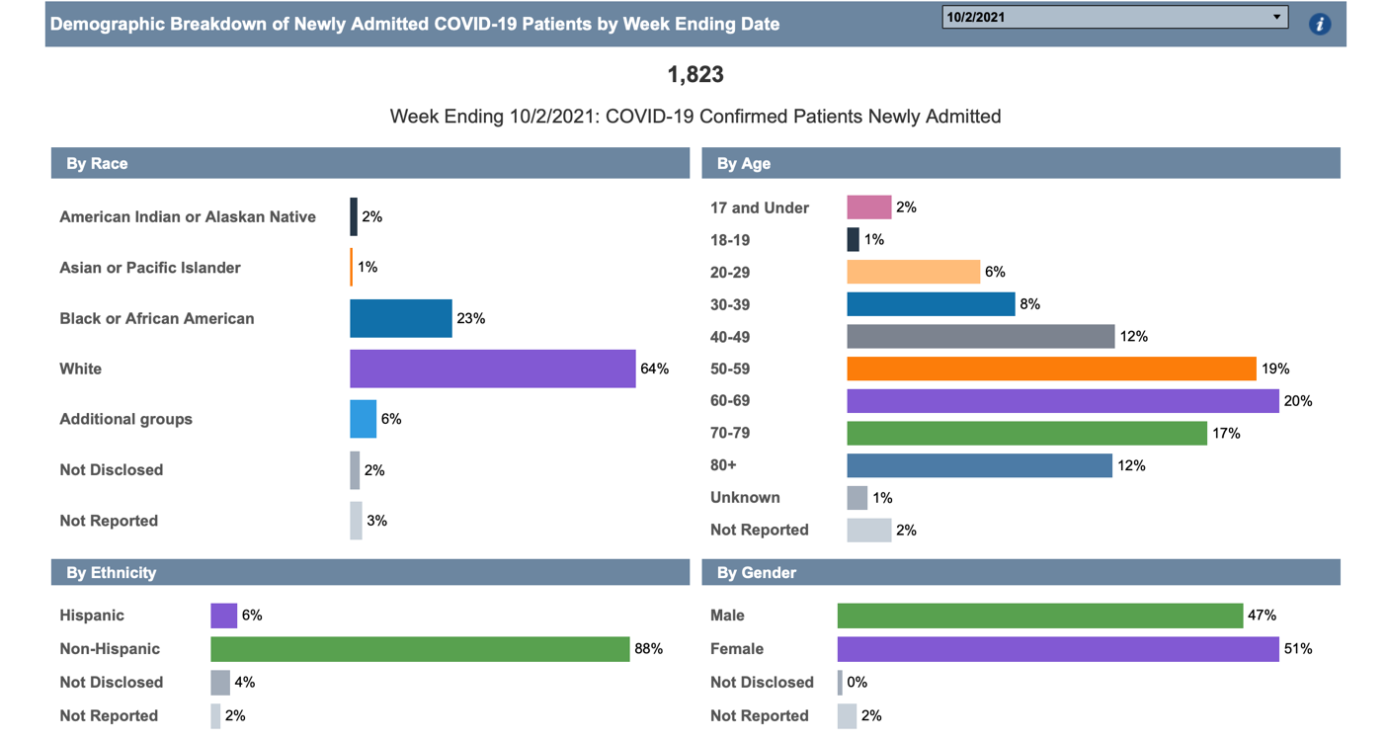
October 3, 2021, with 1,823 Confirmed/Admitted newly cases

January 1, 2022, with 2,2297 Confirmed/Admitted newly cases
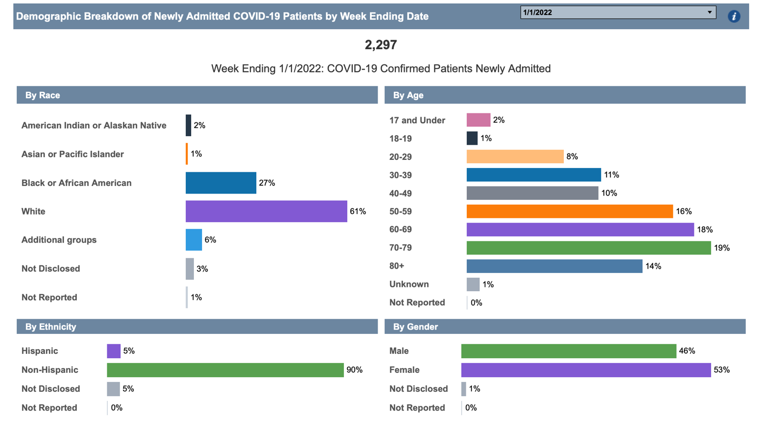

April 2, 2022, with 274 Confirmed/Admitted newly cases
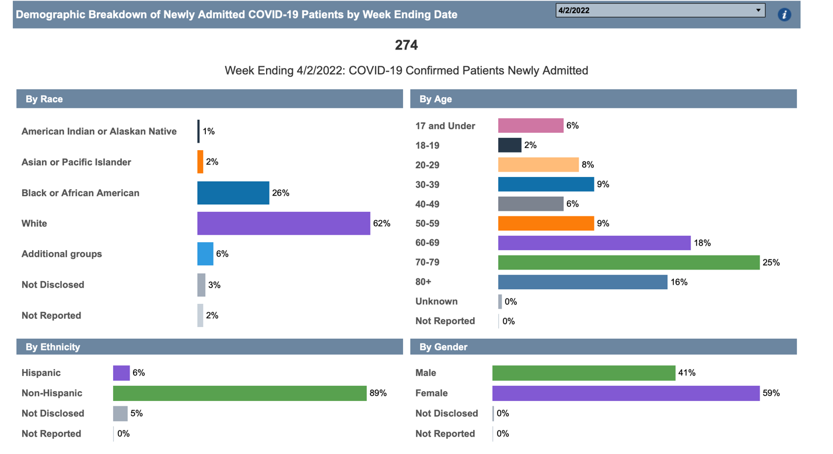

July 2, 2022, with 895 Confirmed/Admitted newly cases
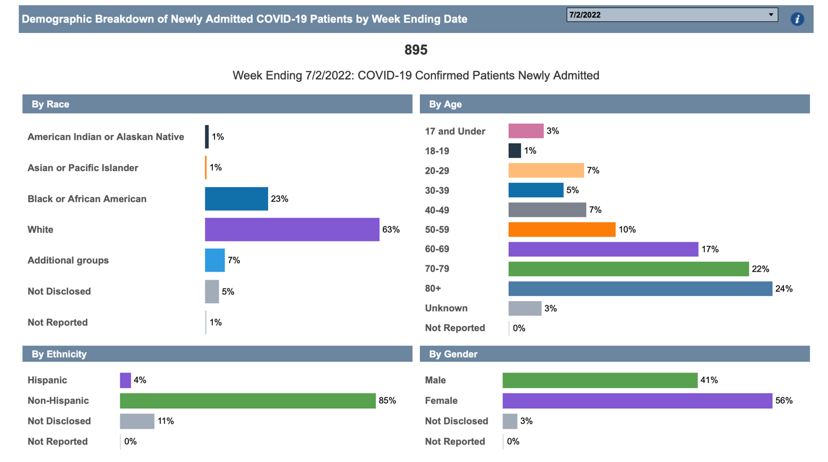

October 1, 2022, with 837 Confirmed/Admitted newly cases
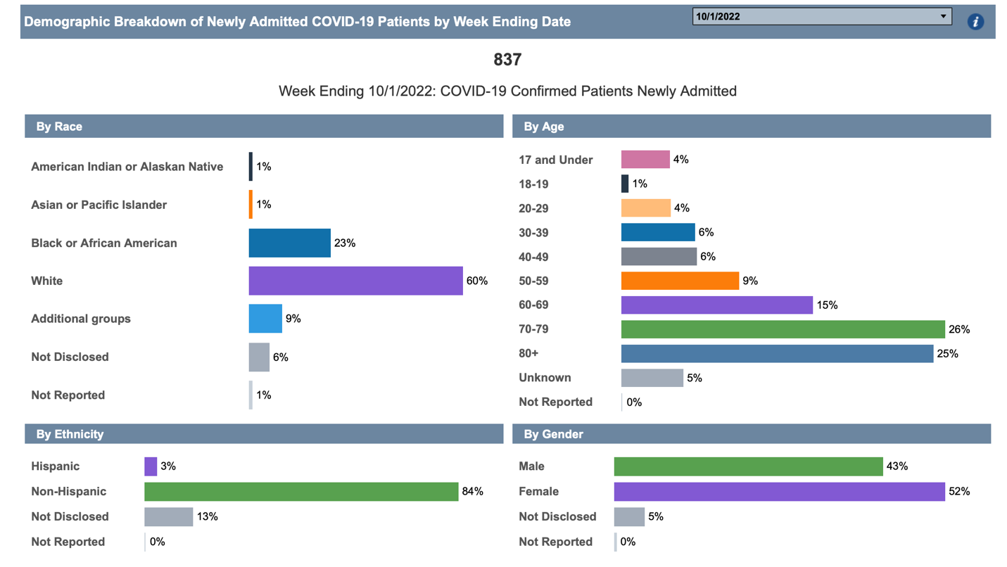

January 7, 2023, with 1,662 Confirmed/Admitted newly cases
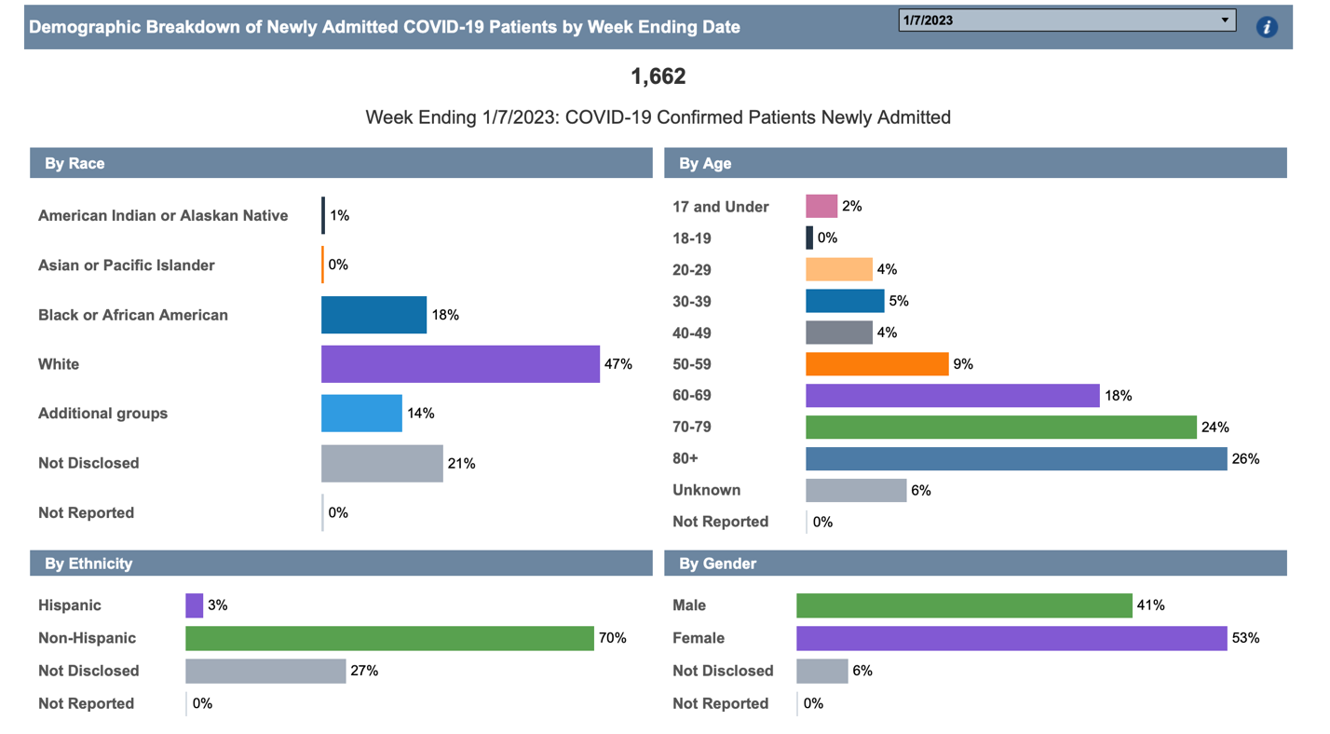
March 11, 2023, with 516 Confirmed/Admitted newly cases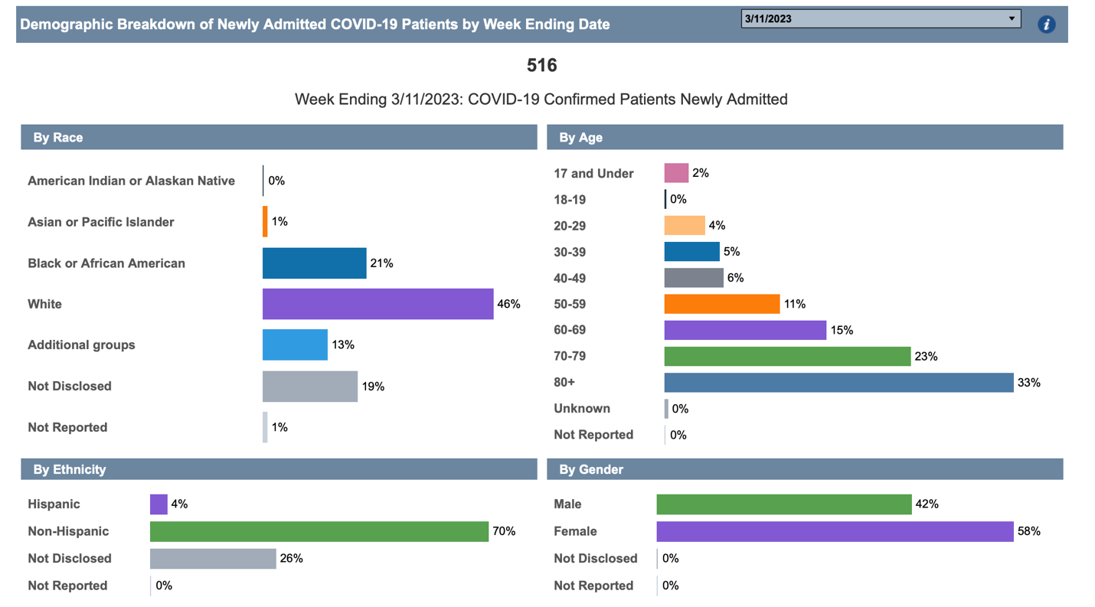
Now that we have a literal picture of how the trend of COVID affected demographics, we can now analyze on just who was affected most. For Race, on an average, whites are being hospitalized more here in the state of North Carolina, but does that mean that they are the ones that its targeting, no. It could be that they are the ones that are able to get medical care. According to the NCDHHS site, 72% of the white population ended up with COVID. 23% represented Blacks, 4% Asian, 2% American Indian and 10% Hispanic. Moving into gender, females are also a target where almost 50% of hospitals represent them versus men. Also looking at the age groups, typically those ranging from 65 years of age and over are the ones that are ending up in the hospitals. Now, that doesn’t mean that other age groups aren’t being admitted, but it does mean that the younger people are able to recover at home. 70 – 79 years of age also make up a huge portion on those hospitalizations too. From the number of hospitalization’s, let’s look to see just how many of them represented ICU beds.
Ages | Hospitalizations | ICU | Deaths
0-17 | 30 | 4 | 42
18-49 | 1803 | 300 | 2120
50-64 | 5253 | 977 | 6203
65+ | 23450 | 1526 | 24995
Totals | 30536 | 2807 | 33360

Table 2- Age

From table 2 we can see the breakdown of the age groups and just how many of them ended up being just hospitalized or in ICU. What’s more questionable would be that some people didn’t even make it to the hospital, some died at home or in other facilities. Meaning, some did not receive the proper care that they needed and some of that could have been demographics, and some could have been that the hospitals were full and simply weren’t accepting any more patients. That then leads us to the next part, death rates.

2.4 Death Rate
Moving into the next part of the data, death rate. We are going to look and see just how many people lost their lives and based on that what was the breakdown of the demographics. Did one race suffer more than the other or was it equal across the board. Per the USA Facts for North Carolina, the graph below outlines the deaths per day starting from March 18, 2020, which was the beginning of the “lock down”, until January 8, 2023.
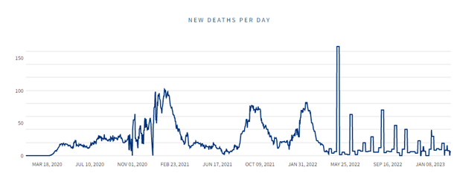
This graph represents the death rate on a 7-day average. Deaths by date of death show deaths on the date the person died. Deaths are typically reported within hours or days. As new deaths are reported, they are included in the date the person died, and so previous dates can change. Deaths include those among molecular (PCR) and antigen positive cases. Based on the graph we can see that on average we were peaking about 50 – 100 deaths per day, especially during the early months of COVID. During further research I was able to find out what it meant to have a “COVID-19 death”. The person had to have one of the two options listed below:
- Had to positive molecular (PCR) or antigen test for COVID-19, who died without fully revering from COVID-19, and who had no alternative case of death identified. Deaths are reported by hospitals and clinicians directly to the local and state health departments. Once reported, NCDHHS or LHD staff manually enter the death by date of death, into NC COVID, or
- After January 1, 2022, was reported as a COVID-19 case in NC COVID and had COVID-19 listed as the primary or underlying cause of death on their death certificate.
NCDHHS conducts ongoing data quality checks on the NC COVID data, including ensuring that there is not duplicate cases, and removing cases that are not NC residents, consistent with national guidance. After conducting data quality check, the data are used to calculate the COVID-19 metrics posted on the NCDHHS website.
2.5 What does this data represent?
The data shows us that for one people over the age of 65 are the ones that are being affected more from COVID. They are the ones that have underlying conditions or pre-existing conditions which makes them more likely to be affected. From table 2 we see that those that are 65+ had more than 24,000 deaths which is more than doubled compared to those 50 to 64 years of age. That is a huge gap in terms of death. In terms of Males and Females, we can see that more males died, but not females. My thoughts on that would be that most of the time women will go and see a doctor or go to the hospital when they don’t feel good, but at times men wont. They will “wait it out” which at times can cause more problems than good. From that we see that it resulted in more of them dying than women. Lastly, from the data that was taken off the NC COVID dashboard, we can conclude that more white people were in the hospital than any other race, but were they the ones that had the highest death rate over any other race?
The UNC School of Medicine released an article called, “Study Demonstrates Blacks and Hispanic people in NC Have Highest Risk of Dying at Home Due to COVID-19”. Within this article you are able to see that using death certificates from March 1, 2020 – December 31, 2021, that at least 7.1% of 22,646 deaths due to COVID-19 occurred at home. From this article I was able to gather that whites had access to better health facilities that prevented them in losing their lives. I’m sure the Blacks and Hispanics, were in areas where they couldn’t get proper healthcare and part of that I’m sure contributes to them not having insurance.

Chapter 3 – Methods
3.1 – Mathematical Modeling
Mathematical Modeling can be used to understand how the virus COVID-19 can spread within a population. Mathematical functions can be applied as tools to describe just hoe infectious diseases propagate among people. Mathematical Modeling generates a picture or a “model” in which the diseases can be represented using graphs, charts, and tables. These models provide insight on how they spread and how we need to take control. The World Health Organization (WHO) issues an immediate countermeasure to control the spread of COVID, one of which was the wearing of a mask the proper way and washing your hands.

3.2 – SIR Model
Initially The SIR Model is one way to predict, by it being a homogeneous mixture of the infected with the susceptible populations and that the total population is constant in time. In a normal SIR model, you have three categories: Susceptible, Infected, or Recovered. In an equation you would assume that the infected can interact with the susceptible, infecting them and converting them into infected as well, As the infected increases, the susceptible declines. Infected people can also recover and are then assigned to the Recovered category.
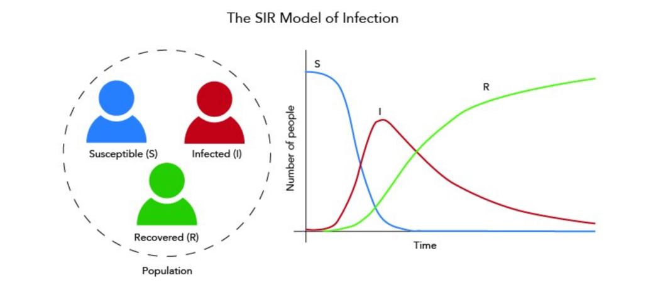
These equations can be used to solve and understand just how the number of people infected changes over time. You can have additional categories introduced into the basic model such as the age of someone or their race.
In some cases, you can use another form of the SIR model, which would be SEIR. With this you are adding an important component which would be the “Exposed” because this is how someone was able to catch COVID, they had to be physically exposed to it. The main set up of this model would be hospitalized, ICU and death versus age and ethnicity. Meaning, you are taking the asymptomatic and symptomatic cases, death, needs of hospital beds all in efforts to control measure and the interventions to decrease the number of cases.

3.3 – Chi-Square Test (Contingency Table)
What is a contingency table, it’s a table that is a combination of two categorical variables. In school we learned two-way tables, or a crosstabulation. These tables help us classify outcomes of one variable in rows and the other in columns. These values are the row and column intersections for unique combinations of two variables. I will use a contingency table or a Chi-square test, to understand the relationship between my categorical variables. For example, the relationship between gender (male/female) and death or hospitalization. Below in the table you can see an example of what one looks like below:
 | Sample A | Sample B | Row total
Category A | A | B | A+B
Category B | C | D | C+D
Category C | A+C | B+D | Grand Total:  A+B+C+D

From this example we see that we have three different categories and within each category we see that they have two subgroups or samples, Samples A and Samples B. The values (A, B, C, D) within each subgroup represent people, which are then identified as a number, which make up the category itself.
In the data we will have observed value, which is the values (A, B, C, D). Basically, this is information that was “surveyed” and is already accounted for in the table. Next you will have the expected values, which is just what it says. It is the estimation of how many people belong to one group. It is the total of one of the columns or rows from the information that was gathered. To calculate an expected value for a cell in a contingency table, you are to compute the product of the row total for the row and column containing the cell, and then divide that computed product by the grand total. It will look something like this:

$$Expected value=\frac{\left(Row total\right) x (Column total)}{Grand total }$$

3.4 – Odd Ratio
Now, when looking at the Odd Ratio (OR) , you are taking the measure of association between an exposure and an outcome. This test represents the outcome that will occur when a particular exposure compared to the odds of the outcome that occurs in the absence of that exposure. Typically, Odds Ratio is used in case-control studies. With that being said, I thought it would be best to this test based on the data that I have and how I wanted to compare the different components. Being able to determine whether a particular exposure is a risk factor for the outcome. Based on the CDC on how to read the results/ data when completing the Odds Rations you do so by using these three factors:
- OR = 1 Exposure does not affect odds of the outcome – Indicates that the odds of the exposure among case-patients are the same as, or like, the odds of exposure among the controls. Meaning the exposure is not associated with the disease.
- OR > 1 Exposure associated with higher odds of outcome – indicates that the odds of exposure among case-patients are greater than the odds of exposure among controls. The exposure might be a risk factor for the disease.
- OR < 1 Exposure associated with lower odds of outcome – indicates that the odds of exposure among case patients are lower than the odds of exposure among controls. The exposure might be a protective factor against the disease.
When determining the Odds Ratio for a set of data, you first must put the information into a two-way table. From doing so then input your information into the formula.
 | Disease X (Cases) | Healthy (Controls)
G1 variant (exposed) | 45 a | 55 b
NO G1 variant | 20 c | 80 d

$$Odd Ratio= \frac{a/c}{b/d}$$

Chapter 4 – Results
4.1 – Odds Ratio
While completing the odds Ratio test, the following comparisons were used to show if there was some sort of relationship in the data using the data from Tables 1 and 2.
- Age- ICU vs. Death
- Age – Hospitalization vs. Death
- Sex – ICU vs. Death
- Sex – Hospitalization vs. Death

4.2 – Age – ICU vs. Death
Age | ICU | Death | Total | Odds
0-64 | 1281 | 8365 | 9646 | 6.5301
65+ | 1526 | 24995 | 26521 | 16.3794
Total | 2807 | 33360 | 36187
Table 3 - Age ICU vs. Death

We can see that the odds for individuals over the age of 65 had an odd of 16 vs. the 7. From this it gave us an Odd Ratio value of 0.3987. This data is showing us what we already know, and what the research has shown thus far. Those over the age of 65 are at more risk and are more likely to die.
Age | Hospitalization | Death | Total | Odds
0-64 | 7086 | 8365 | 15451 | 1.1805
65+ | 23450 | 24995 | 58445 | 1.0659
Total | 30536 | 33360 | 63896
4.3 – Age – Hospitalization vs. Death

Table 4- Age Hospitalizations vs. Death

From this comparison we see that the odds for hospitalization and death are around the same. The Odd Ratio for the two gave us a 1.1075. meaning that their odds are very much similar.

4.4- Sex – ICU vs Death
Sex | ICU | Death | Total | Odds
Male | 186 | 17551 | 17737 | 94.3602
Female | 2671 | 15809 | 18480 | 5.9188
Total | 2857 | 33360 | 36217
Table 5- Sex ICU vs. Death
The Odd Ratio value is 15.9426 which is very high. Male odds are also very high, leading to the research that we have found. Males are more likely to die than females and the data supports that. Less males ended up in the ICU than females. Female’s numbers are more than tripled.

4.5 – Sex Hospitalization vs. Death
Sex | Hospitalization | Death | Total | Odds
Male | 14020 | 17551 | 31571 | 1.2519
Female | 16516 | 15809 | 32325 | 0.9572
Total | 30536 | 33360 | 63896
Table 6- Sex Hospitalizations vs. Death
The Odds Ratio of 1.3078 represents that data above, this doesn’t show a strong relationship. There isn’t much difference in the Hospitalization and the deaths for males in females.

Chapter 5 – Conclusion
5.1 – Summary
COVID, something that I’m sure that I will continue to hear for the rest of my life. It’s been an eye opener, because you never really know just how bad things are until you dig a little deeper. COVID has made me become more conscious of what I do and how I do it. For those that were already germ freaks, they have become more germ freaks, like me. I know I wash my hands more and sanitize them more that I have ever done. I am constantly wiping things down, as well as keeping my distance from others. My mask has not been removed since the beginning of April 2020 and I don’t know when I will remove it. My research has enhanced my germ senses.
With all the people that have lost their lives due to COVID is scary. It has killed off generations of people, and it’s still killing people off. Men need to wake up and become more aware of their health. They are the ones that are losing their lives because they are don’t take their health as serious. They tend to go long periods of times without going to the doctor and checking on themselves as a result they are the ones that are dying. When it comes to women, they have a higher rate of being in the hospital or even ending up in the ICU, but as usually, they will go see about themselves when they know something isn’t right. Even with higher rates than men, we still aren’t losing our lives behind this pandemic.
As of May 1, 2023, we will no longer be in a pandemic, everything is returning to “normal” whatever that means. My fear is that even with numbers still going up, reporting will stop, and people guards will be let down. My data shows a decrease, but the decrease is not steady enough to act as if everything is fine. This is just the beginning of what could be the worse. The dashboard for the state showed that numbers still considered to be high, even with a vaccination.
5.2 – Primary Findings from Study
Individuals over the age of 65 were targeted most throughout this pandemic. They are the ones with the prior health issues/ concerns and weren’t able fight it off. Majority of the people that ended up in the hospital or either ICU were from this age group. Also as stated earlier, males were the ones with the higher death rates compared to women even though more women ended up in the hospital than men. The Odds Ratio proved these findings and supported what the research said.
5.3 – Ways to improve future studies
There are a couple of things that could have made this research better, and that is one, finding more in terms of race. A lot of that data didn’t give you the full breakdown as it did when comparing males to females. I would have like to dig more to see why more males died and what was the contributing factor and what could have been done to prevent it. I feel as if I had more data that included the race, then I could’ve done a big comparison to how the difference races were affected to COVID. Even though we do know that the African American community was targeted and hit hard, they weren’t the ones that were getting COVID more, whites were. Also, another thing that could be an extension to research would be of the people that were in the count of having had COVID, how many of them had it more than one time. Were there any repeaters that were listed in my data? I also wonder if the numbers would’ve been higher if I had just gone based on the positive test rates versus death and not have done a comparison with hospitalization and ICU. Lastly, I wonder how many people had COVID and never reported it?

Reference:
Academic.oup.com. (n.d.). Retrieved April 28, 2023, from https://academic.oup.com/pcm/article/3/2/85/5841934
Age, sex, existing conditions of covid-19 cases and deaths. Worldometer. (n.d.). Retrieved April 28, 2023, from https://www.worldometers.info/coronavirus/coronavirus-age-sex-demographics/
Ahmed, I., Modu, G. U., Yusuf, A., Kumam, P., & Yusuf, I. (2021, February). A mathematical model of coronavirus disease (COVID-19) containing asymptomatic and symptomatic classes. Results in physics. Retrieved April 28, 2023, from https://www.ncbi.nlm.nih.gov/pmc/articles/PMC7787076/
Author links open overlay panelZenebe Shiferaw Kifle, Highlights•A nonlinear deterministic mathematical model for COVID-19 transmission dynamics is proposed and analyzed.•An expression for the basic reproduction number is obtained and its sensitivity with respect to the model parameters is also discussed.•Th, & paper, A. I. this. (2022, January 15). Mathematical modeling for Covid-19 Transmission Dynamics: A case study in Ethiopia. Results in Physics. Retrieved April 28, 2023, from https://www.sciencedirect.com/science/article/pii/S2211379722000122
Bachar, M., Khamsi, M. A., & Bounkhel, M. (2021, May 14). A mathematical model for the spread of covid-19 and control mechanisms in Saudi Arabia - advances in continuous and discrete models. SpringerOpen. Retrieved April 28, 2023, from https://advancesincontinuousanddiscretemodels.springeropen.com/articles/10.1186/s13662-021-03410-z
Centers for Disease Control and Prevention. (2023, April 26). Covid-19 provisional counts - weekly updates by select demographic and geographic characteristics. Centers for Disease Control and Prevention. Retrieved April 28, 2023, from https://www.cdc.gov/nchs/nvss/vsrr/covid_weekly/index.htm#Race_Hispanic
Choi, Y., Park, M., Kang, D. H., Lee, J., Moon, J. Y., & Ahn, H. (2019, August). The quality of dying and death for patients in Intensive Care Units: A single center pilot study. Acute and critical care. Retrieved April 28, 2023, from https://www.ncbi.nlm.nih.gov/pmc/articles/PMC6849018/
Color of coronavirus: Covid-19 deaths analyzed by race and ethnicity. APM Research Lab. (n.d.). Retrieved April 28, 2023, from https://www.apmresearchlab.org/covid/deaths-by-race
Covid‐19: A multiwave sir‐based model for learning waves. (n.d.). Retrieved April 28, 2023, from https://onlinelibrary.wiley.com/doi/full/10.1111/poms.13681
Dai, Z. (n.d.). Covid-19 model. Retrieved April 28, 2023, from https://drziweidai.com/COVID-19.html
Demographic science AIDS in understanding the spread and fatality rates ... (n.d.). Retrieved April 28, 2023, from https://www.pnas.org/doi/10.1073/pnas.2004911117
Dessie, Z. G., & Zewotir, T. (2021, August 21). Mortality-related risk factors of COVID-19: A systematic review and meta-analysis of 42 studies and 423,117 patients. BMC infectious diseases. Retrieved April 28, 2023, from https://www.ncbi.nlm.nih.gov/pmc/articles/PMC8380115/
Dot. (n.d.). North Carolina covid-19 (Coronavirus) Hospital Capacity. Citizen. Retrieved April 28, 2023, from https://data.citizen-times.com/covid-19-hospital-capacity/north-carolina/37/
Khan, Z. S., Bussel, F. V., & Hussain, F. (2020, October 8). A predictive model for covid-19 spread – with application to eight US states and how to end the pandemic: Epidemiology & Infection. Cambridge Core. Retrieved April 28, 2023, from https://www.cambridge.org/core/journals/epidemiology-and-infection/article/predictive-model-for-covid19-spread-with-application-to-eight-us-states-and-how-to-end-the-pandemic/C932EED69C85E9236808A24862BB1BE3
Latoya Hill Follow @hill_latoya on Twitter and Samantha Artiga Follow @SArtiga2 on Twitter Published: Aug 22, 2022. (2022, August 22). Covid-19 cases and deaths by Race/ethnicity: Current data and changes over time. KFF. Retrieved April 28, 2023, from https://www.kff.org/coronavirus-covid-19/issue-brief/covid-19-cases-and-deaths-by-race-ethnicity-current-data-and-changes-over-time/
Morris, K. (2022, September 16). Study demonstrates black and Hispanic people in NC have highest risk of dying at home due to covid-19. Institute for Global Health and Infectious Diseases. Retrieved April 28, 2023, from https://globalhealth.unc.edu/2022/09/study-demonstrates-black-and-hispanic-people-in-nc-have-highest-risk-of-dying-at-home-due-to-covid-19/
NC covid-19. North Carolina COVID-19. (n.d.). Retrieved April 28, 2023, from https://nc-covid.org/demographics.html
North Carolina: All Race & Ethnicity Data. The COVID Tracking Project. (n.d.). Retrieved April 28, 2023, from https://covidtracking.com/data/state/north-carolina/race-ethnicity
Sundaram, S. S., Melquist, S., Kalgotra, P., Srinivasan, S., Parasa, S., Desai, M., & Sharma, P. (2022, July 29). Impact of age, sex, race, and regionality on major clinical outcomes of COVID-19 in hospitalized patients in the United States - BMC Infectious Diseases. BioMed Central. Retrieved April 28, 2023, from https://bmcinfectdis.biomedcentral.com/articles/10.1186/s12879-022-07611-z/tables/2
Tang, Y., & Wang, S. (2020, December). Mathematic modeling of COVID-19 in the United States. Emerging microbes & infections. Retrieved April 28, 2023, from https://www.ncbi.nlm.nih.gov/pmc/articles/PMC7241447/
Zeb, A., Alzahrani, E., Erturk, V. S., & Zaman, G. (2020, June 29). Mathematical model for coronavirus disease 2019 (COVID-19) containing isolation class. BioMed Research International. Retrieved April 28, 2023, from https://www.hindawi.com/journals/bmri/2020/3452402/

